CareOwn HMS — Complete End-to-End Workflow Guide

Part 2 of 3: Every Business Workflow, Screen by Screen
Every business workflow from patient registration through discharge, with exact fields, buttons, and validation rules as they appear on screen. Each section names the staff role who normally performs it.

The Complete Patient Journey
Outpatient path: Patient Registration → Appointment / Walk-in → Queue Token → OP Consultation → Lab / Pharmacy → OP Billing

Inpatient path: IP Admission → Ward Allocation → Running IP Bill → Initiate Discharge → Finalize Discharge → Discharge Summary

Table of Contents
- Patient Registration
- Appointments & Direct Visit
- Token / Queue Management
- OP Consultation (Case Sheet)
- ICD Diagnosis Coding
- Laboratory Workflow
- Radiology
- Pharmacy Workflow
- IP Admission
- Nursing & Doctor Rounds
- Operation Theatre
- Billing (OP & IP)
- Discharge
- Follow-up Visit
- Insurance
- Patient Reports & WhatsApp Share
- Reports Index

1. Patient Registration
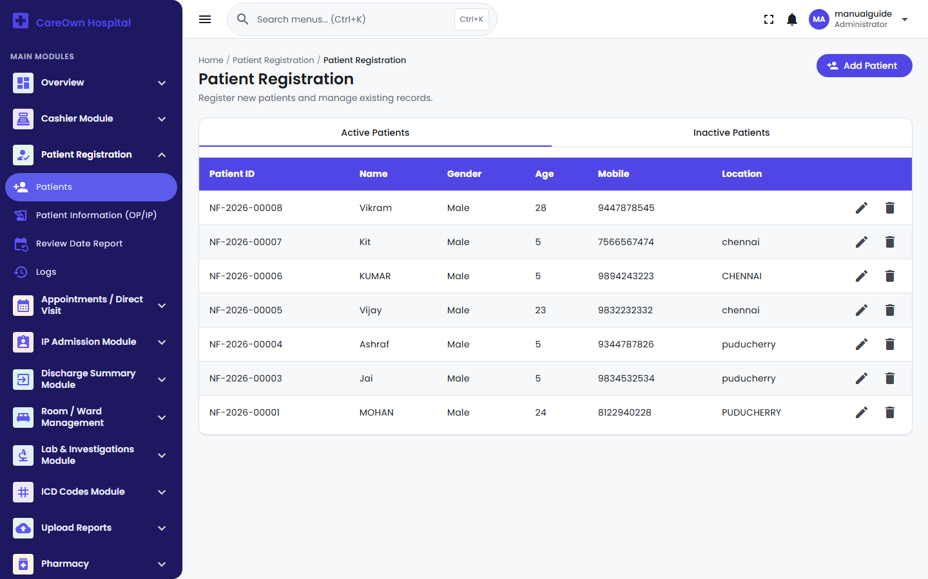
Patient Registration - Active Patients list

Performed by: Receptionist

Navigation: Patient Registration → Patients

Every workflow in the system starts from here — a patient must exist in the registry before an appointment, admission, lab test, or bill can be created against them.

Steps:

- Click Add Patient.
- Enter Patient name, Gender (Male/Female), Age (1–100), Mobile number (exactly 10 digits), and Location — all required.
- Choose Registered Via — Front Office/Reception, OP Appointment, IP Admission, Pharmacy, Lab/Investigations, or Insurance (this only appears when adding, not editing).
- Click Add patient. The system assigns a Patient ID automatically (format NF-2026-00001).

Important: There is no automatic duplicate-patient warning when registering someone who may already exist. Always search first (by name, Patient ID, or mobile number) before adding a new record, to avoid creating a second entry for the same person.

Deleting a patient is a soft delete by default — they move to the Inactive Patients tab and can be restored. A separate, clearly-labeled Delete permanently action on that tab is the only way to actually erase a record, and cannot be undone.

To see everything ever recorded about one patient in one place — every appointment, admission, lab test, bill, payment, cancellation, and uploaded file — use Patient Registration → Patient Information (OP/IP).

2. Appointments & Direct Visit
Performed by: Receptionist

2.1 Booking an Appointment
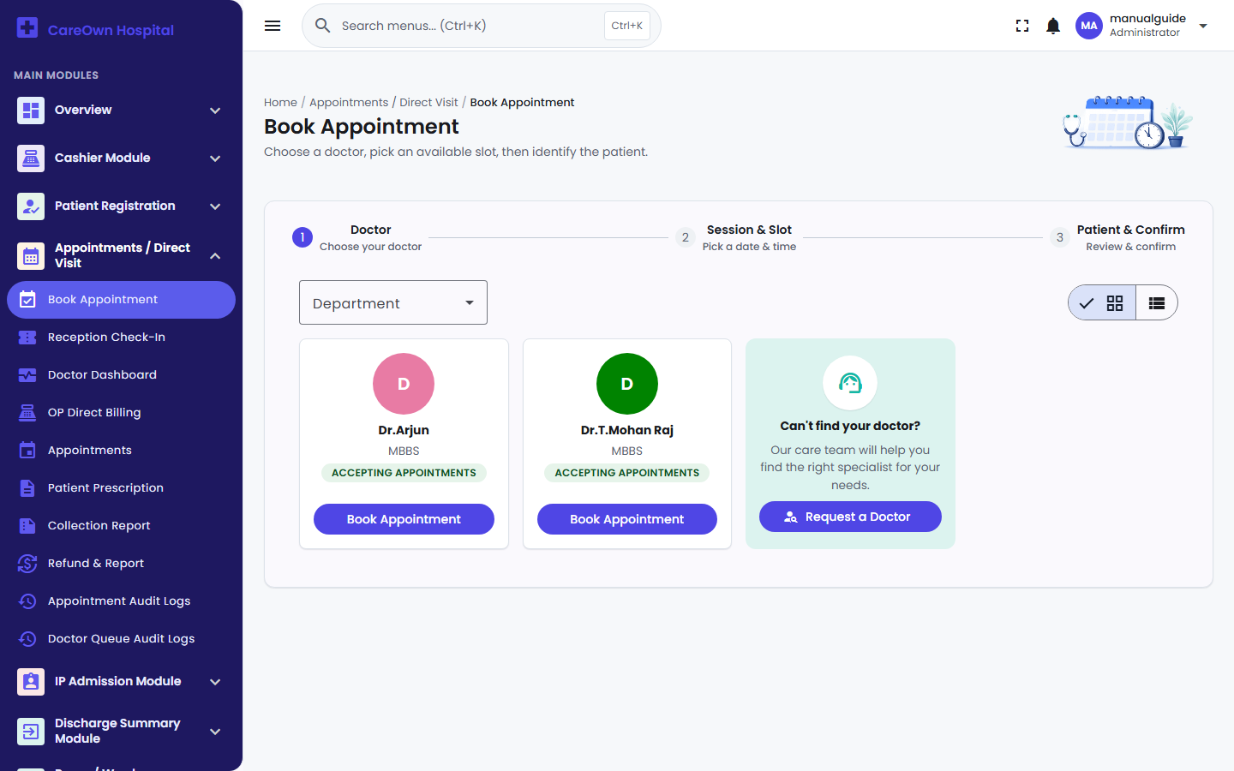
Book Appointment wizard - choosing a doctor

Navigation: Appointments / Direct Visit → Book Appointment

A 3-step wizard, doctor-first:

- Doctor — filter by department if needed, then click Book Appointment on the doctor's card. Only doctors marked "Accepting Appointments" appear.
- Session & Slot — pick a day from the week strip, then a time slot under the Morning/Afternoon/Evening/Night session headers. Slots are generated live from the doctor's weekly availability (Part 1, Chapter 3.4) minus whatever's already booked — nothing is pre-stored.
- Patient & Confirm — search for the patient (they must already be registered — this wizard cannot create a new patient), add optional notes, then click Confirm Appointment.

On success you can Share on WhatsApp the confirmation directly to the patient's mobile number.

Note: No fee is entered at booking time — the doctor's consultation fee (set on their Consultant record) is what gets charged when the appointment is later billed.

Cancelling an appointment: Open the appointment and choose Cancel; a reason is required. Cancelling automatically cancels any live Doctor Queue token tied to it too, so nothing is left stranded in the queue.

2.2 OP Direct Billing (Walk-in Charges)
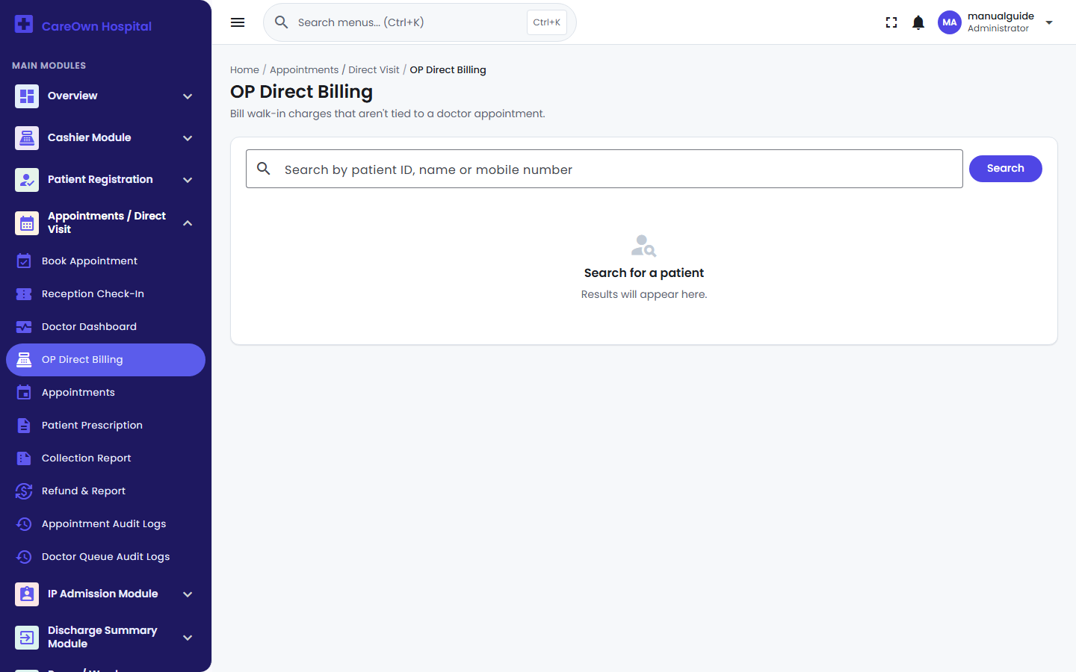
OP Direct Billing screen

Navigation: Appointments / Direct Visit → OP Direct Billing

Use this for charges that have nothing to do with a doctor appointment — a registration fee, a standalone procedure, anything billed on the spot. Unlike an appointment, this bills immediately — there's no approval step.

- Search for and select the patient.
- Under Billing Items, pick a Category and Component, set the Qty (Amount auto-fills, but is editable).
- Under Payment Details, choose a Payment Mode (Cash, Card, UPI, Net Banking, Insurance, Other) and, optionally, a Consultant to attribute the charge to.
- Click Submit — a receipt opens immediately.

Warning: Don't confuse this with "Register Walk-In" on the Reception Check-In screen (Chapter 3) — that creates a live Doctor Queue token for a specific doctor and goes through the normal Waiting → Called → Complete flow. OP Direct Billing has no doctor queue involvement at all.

2.3 Refunds
Navigation: Appointments / Direct Visit → Refund & Report

- Enter the Invoice Number and click Search (works for both appointment and direct-billing invoices).
- Click Approve Refund, enter the Refund Amount (cannot exceed what was actually paid) and a reason.
- Confirm. A refund receipt opens.

Important: An invoice can only be refunded once. The system will show you the date, refund number, and amount of a prior refund instead of letting you process a second one.

3. Token / Queue Management (Doctor Queue)
Performed by: Receptionist & Doctor

Note: Doctor Queue is an optional add-on, turned on per-hospital in Clinic Settings. If it's off for your hospital, these three screens simply aren't reachable, and everything else (booking, billing) works exactly the same without them.

3.1 Reception Check-In
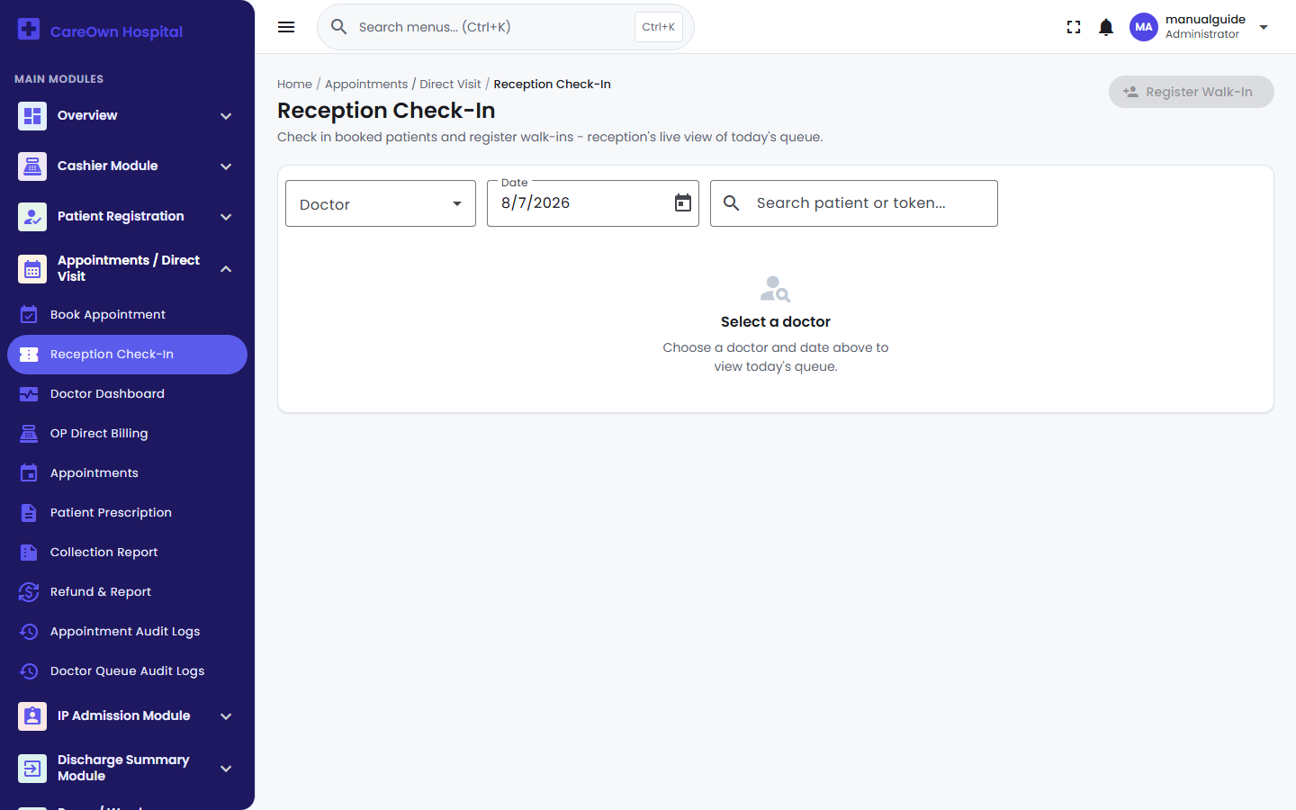
Reception Check-In worklist

Navigation: Appointments / Direct Visit → Reception Check-In

Select a Doctor and Date to see that doctor's live worklist (auto-refreshes every 15 seconds), filterable by status: All / Awaiting Check-In / In Queue / Completed / Skipped / No-Show / Cancelled.

- A patient with a booked appointment gets a Check In button — click it to issue them a token.
- A patient with no appointment can be added via Register Walk-In — search/select the patient, pick the doctor, optionally mark "Register as Emergency", and issue a token.

Tokens follow the pattern A001 (a letter prefix from the doctor's settings + a daily sequence number).

3.2 Doctor Dashboard
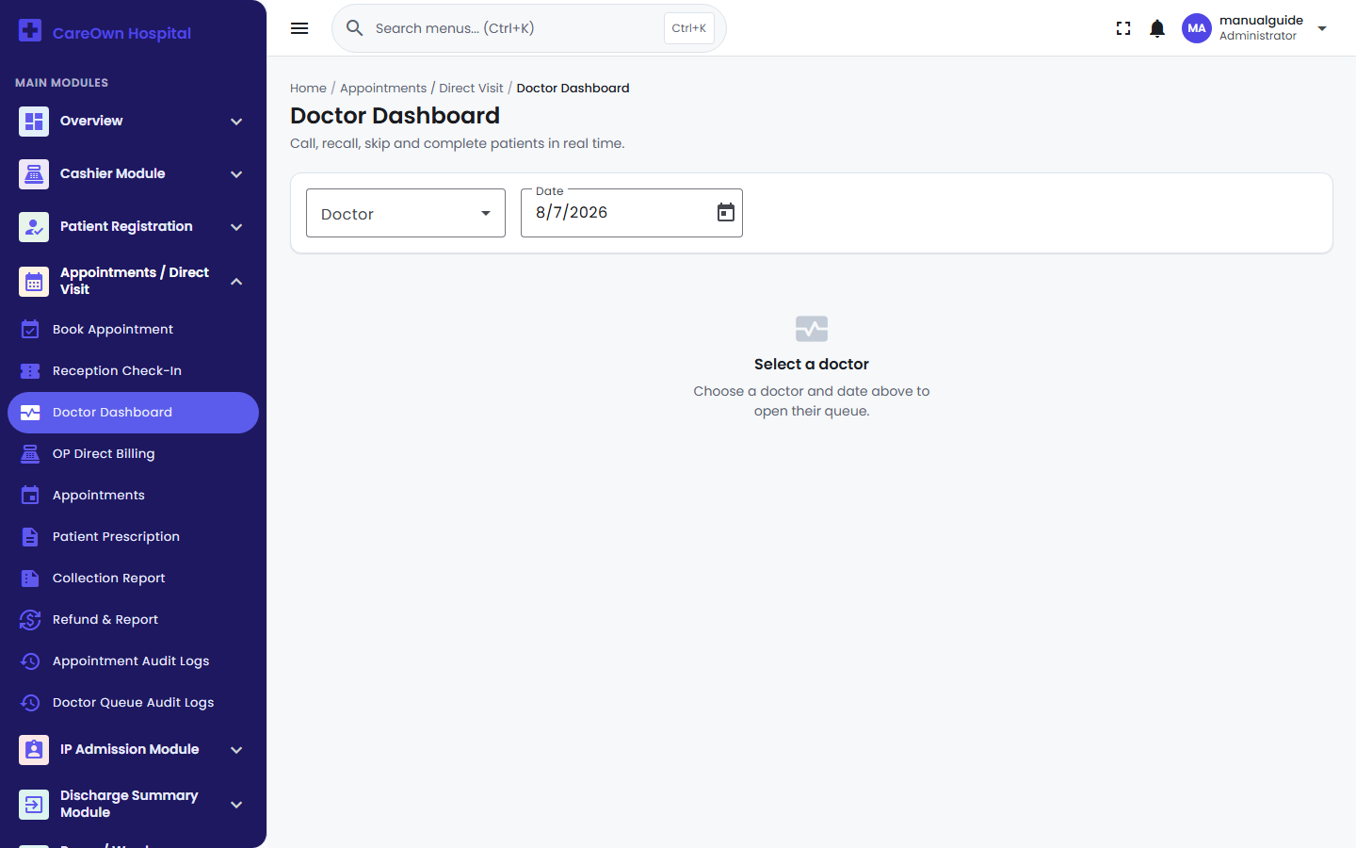
Doctor Dashboard

Navigation: Appointments / Direct Visit → Doctor Dashboard

The doctor's live control panel. Four buttons drive the whole queue:

Button | What it does
Next Patient | Calls the next highest-priority waiting patient
Recall | Announces the currently-called patient again
Skip | Moves the called patient aside (they can be moved back to Waiting later from Reception Check-In)
Complete | Finishes the visit — there is no separate "start consultation" step
An Up Next list shows the waiting line in order, with a per-patient Escalate to Emergency action to reorder someone urgently.

3.3 Display Board (Waiting Room Screen)
A public, no-login TV screen showing only the current token number, the doctor's name, and the waiting count — never a patient's name. Open it directly by its own web address for a given doctor and leave it running on a monitor outside the consulting room. Tap once to enable the sound announcement (browsers require a manual tap before audio can play).

4. OP Consultation (Case Sheet)
Performed by: Doctor (vitals by Nurse)

Navigation: Appointments / Direct Visit → Patient Prescription → View/Edit OP Case Sheet

This is the doctor's consultation note for one specific appointment — vitals, history, diagnosis, and prescription in one screen.

What's recorded:

- Vitals ("Nurse's Assessment") — height, weight, BP, temperature, pulse, SPO2, BMI, and more
- Doctor Initial Assessment — chief complaints, past medical condition, current medication, a lifestyle assessment (activity, sleep, smoking, alcohol), provisional diagnosis, and findings
- Pharmacy Prescription — a repeatable drug table (name, dose, morning/afternoon/evening/night timing)
- Diet, Remarks, and Review Date — the Review Date is what powers the Follow-up Visit reminder (Chapter 14)

Click Save draft to save — this is the only save action; it always overwrites the full case sheet with the current form contents. Saving is what flips the Patient Prescription worklist's status from Pending to Documented.

5. ICD Diagnosis Coding
Performed by: Doctor / Medical Coder

Navigation: ICD Codes Module → ICD Code Search

- Search for the patient by name, mobile, or UHID.
- Click Select Patient, then Manage ICD Codes.
- Click Assign ICD Code — search the code by its number or disease name (from the ICD Code Master), then set Diagnosis Type (Primary / Secondary / Final / Provisional), Diagnosis Status (Active / Resolved / Chronic), and optionally a Severity.
- Save.

The underlying code list itself is managed at ICD Codes Module → ICD Code Master — codes can be added one at a time or imported in bulk via CSV.

6. Laboratory Workflow
Performed by: Receptionist / Billing Staff / Lab Technician

6.1 Requesting a Test
Navigation: Lab & Investigations Module → Lab Requisition

Search for the patient, then choose one of two paths:

- Lab — check off tests from the priced Lab Sub-Category catalog (Part 1, Chapter 3.7), grouped by category, with a running total. Click Submit.
- Investigations — an ad-hoc line-item screen for services outside the fixed lab catalog (X-Ray, Scan, ECG), priced from the OP Billing Catalog instead. Click Submit.

Either way, this creates a PENDING requisition — nothing is billed yet.

6.2 Billing the Requisition
Navigation: Lab & Investigations Module → Lab & X-Ray/Scan Billing

Every pending requisition (both Lab and Investigation types) appears here. Click Approve to open the invoice, enter the Paying Amount, any Discount, and a Payment Mode, then Submit — a printable receipt opens. This is the moment the requisition becomes billed and — for real Lab tests only — lands in the technician's Test Entry queue. Click Cancel instead if the test is no longer needed.

Important: A requisition made up only of ad-hoc Investigations items (X-Ray, Scan, etc., no real lab test) never appears in the technician's result-entry queue — there's nothing to record a result against. Only requisitions with genuine Lab Sub-Category tests generate a technician work item.

6.3 Technician Result Entry
Navigation: Lab & Investigations Module → Lab Entry Queue & Report

- Click View on a queued patient.
- Select the specimen type(s), enter the Result for each ordered parameter, and tick Abnormal Value where applicable (highlights the result in red).
- Click Save to keep working on it later, Draft Copy to save and mark it as a draft, or Approve to finalize.

Warning: Approving a lab report locks it permanently — there is no undo, edit, or reopen action once a report is approved. Double-check results before approving.

Approved reports are printable at Lab Approved Report, which also offers a Share to WhatsApp button per report — this opens WhatsApp with a pre-written message; you still tap Send yourself, and the report file itself isn't auto-attached (use the Patient Reports module's share-link feature, Chapter 16, to send the actual file).

6.4 Lab Refunds
Navigation: Lab & Investigations Module → Payment Refund

Same pattern as OP refunds (Chapter 2.3) — search by invoice number, approve a refund up to the paid amount. Only already-billed requisitions can be refunded, and — same rule as OP — only once per invoice.

7. Radiology
Important: There is no separate Radiology module in CareOwn HMS today. X-Ray and Scan charges are billed through the Lab module's Investigations path (Chapter 6.1) — the menu item itself is literally labeled "Lab & X-Ray/Scan Billing." There is no dedicated radiology worklist, imaging-result entry screen, or PACS-style workflow. If your hospital needs a genuinely separate radiology department workflow, that would be a feature request for a future release, not something to look for in the current system.

8. Pharmacy Workflow
Performed by: Pharmacist

8.1 Purchasing & Stock Receipt
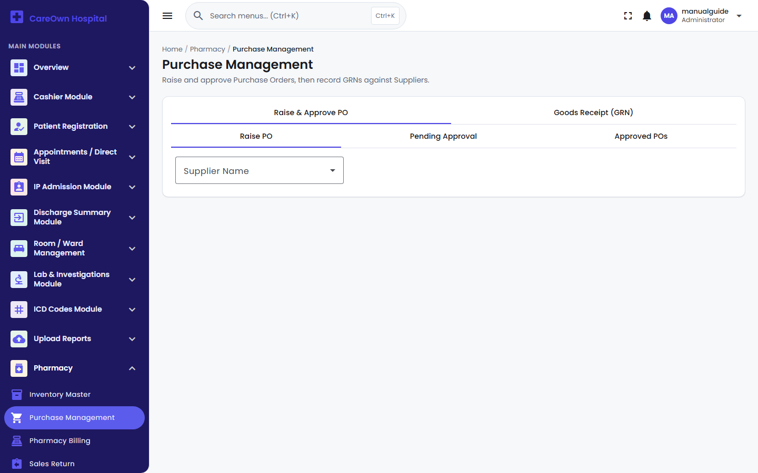
Pharmacy Purchase Management screen

Navigation: Pharmacy → Purchase Management

Flow: Raise PO → Approve PO → Goods Receipt (GRN) → Stock Approved & Sellable

- Raise PO — pick a Supplier, add drugs from the Product Master with quantities, submit. This creates a Purchase Order awaiting approval.
- Approve PO — a reviewer can adjust quantities, then approves it. (Approving a PO doesn't touch stock yet — it just authorizes the purchase.)
- Goods Receipt (GRN) — when the stock physically arrives, record the Supplier, Invoice details, and per-item Batch Number, Expiry Date, MRP, and Purchase Rate. Save as Draft while you're still entering it, or click Approve once it's correct.

Note: Stock only becomes sellable the moment a GRN is Approved — this is the real point where purchased drugs enter inventory. A Draft GRN can still be edited freely; an Approved one is locked.

8.2 Pharmacy Billing (Dispensing)
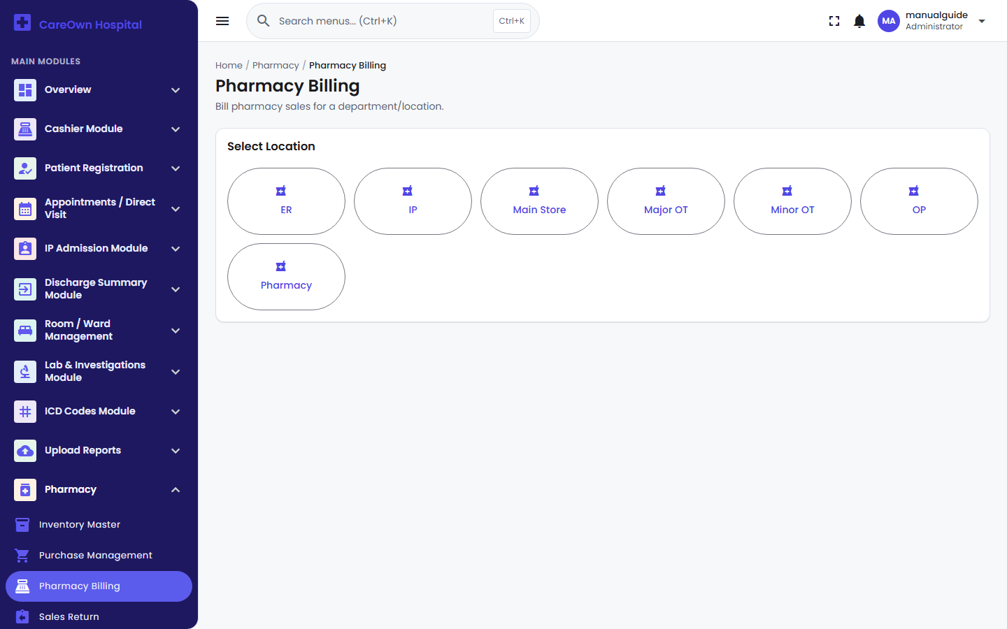
Pharmacy Billing - selecting a dispensing location

Navigation: Pharmacy → Pharmacy Billing

- Select your Pharmacy Location.
- Search for the patient.
- Under Item Entry, search the drug by name — the system shows only actual in-stock batches, with Type/Batch/Expiry/MRP filled in automatically. Enter the quantity and click Add.
- Fill in Billing Information (Payment Mode) and any Discount.
- Click Final Approve — stock is deducted immediately and a bill is printed.

Important: Selecting a batch expiring within 90 days shows an on-screen warning but does not block the sale — it's a heads-up, not a hard stop. The system will, however, refuse to sell more than what's actually on hand for a batch.

Note: Today, every pharmacy bill is entered manually here — a doctor's prescription written on the OP Case Sheet does not automatically create a pending drug request for the pharmacist to bill against. The "Pending Drug Requests" feature exists in the design but isn't wired up to prescriptions yet.

8.3 Returns & Adjustments
- Sales Return (Pharmacy → Sales Return) — look up the original invoice, enter how much of each item is being returned, and submit. This only files the return; Sales Return Approval is the separate screen where stock is actually credited back — a two-step process by design.
- Stock Adjustment — correct stock counts directly (damage, loss, physical count corrections) without going through a sale or purchase.
- Purchase Return — send stock back to a supplier (Normal, Expired, Slow-Moving, Fast-Moving, or Non-Moving return types).

9. IP Admission
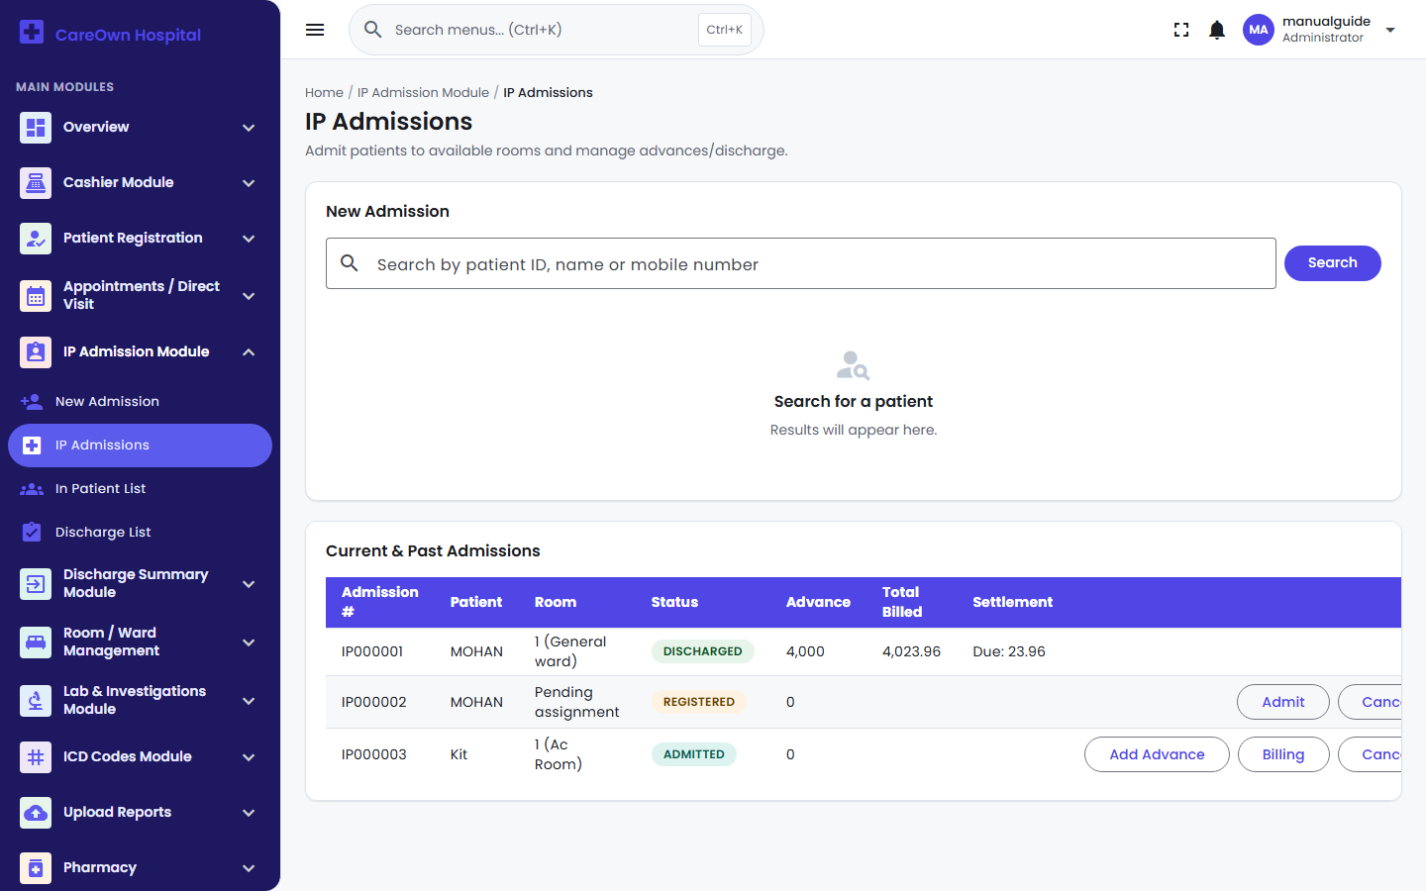
IP Admissions worklist

Performed by: Receptionist / Ward Staff

9.1 Registering & Admitting a Patient
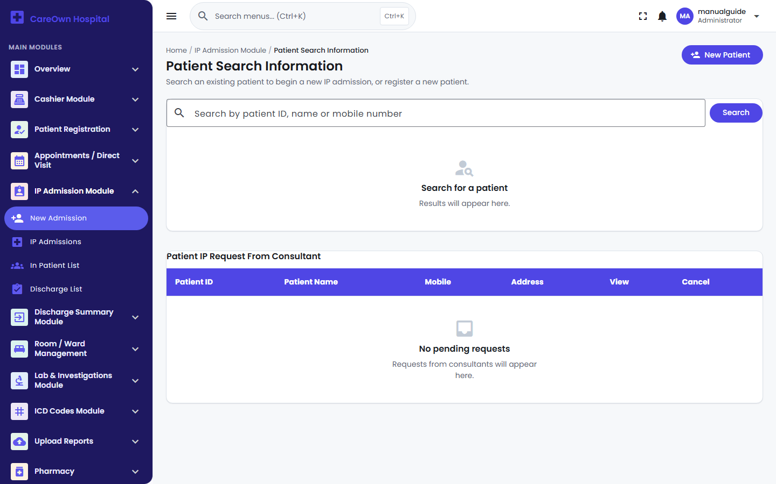
Searching for a patient to admit

Navigation: IP Admission Module → New Admission

Flow: Patient Search → Inpatient Admission Details → Ward Allocation → ADMITTED

- Search for the patient, or register a new one on the spot.
- Inpatient Admission Details — fill in attender/relation details, primary consultant, payment type (Cash/Insurance/Corporate), a preferred room type, and any ICU requirements. Only the Date is strictly required. Click Create — the admission is now REGISTERED, no bed assigned yet.
- From the IP Admissions worklist, click Admit on that registered patient to open Ward Allocation — choose a Ward Type, click Check Room Availability, pick a Room and Bed, optionally record an Advance Amount collected on the spot, then click Admit. Status becomes ADMITTED.

Tip: For a fast, single-step admission with the bed already known, use the quick-admit section directly on the IP Admissions worklist instead of the two-step flow above.

9.2 Moving a Patient to a Different Room (Ward Change)
Navigation: In Patient List → (patient's card) → Ward Change

Pick the new Ward Type and an available Room, then Save. The system automatically closes the billing period for the old room and opens one for the new room, so IP Billing (Chapter 12) correctly splits ward charges between however many rooms the patient actually stayed in.

Note: This is the only room-change mechanism in the system — there is no separate "Ward Transfer" screen. If you've seen it called that elsewhere, "Ward Change" is the same feature.

9.3 In Patient List (Active Census)
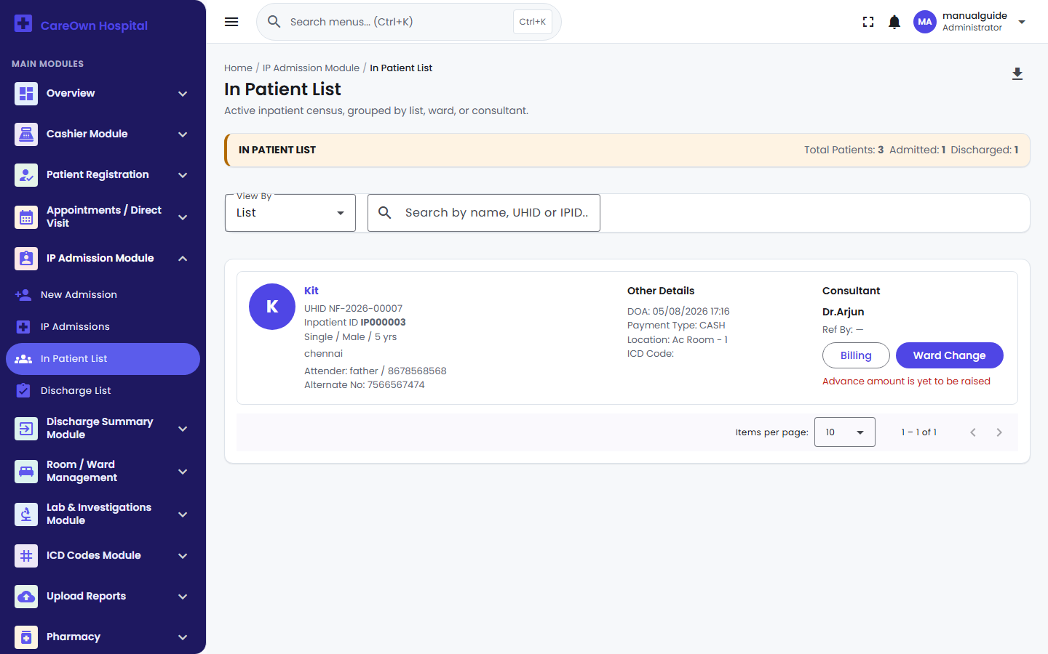
In Patient List - active inpatient census

Navigation: IP Admission Module → In Patient List

Every currently-admitted patient as a card, viewable as a flat List or grouped by Ward or Consultant. Each card links straight to that patient's Billing and Ward Change actions, and flags with a warning banner if an advance amount hasn't been collected yet.

10. Nursing & Doctor Rounds
Important: Neither is a separate module in CareOwn HMS today. There is no nursing station screen, nursing care plan, medication administration record (MAR), or doctor-rounds scheduling/checklist feature. The only nursing-related field that exists is a single "Nurse's Assessment" vitals section inside the OP Case Sheet (Chapter 4) — a form field, not a workflow. If ward nursing documentation and rounds tracking are needed, that is a gap for a future release.

11. Operation Theatre
Important: There is no Operation Theatre (OT) module. No OT scheduling, no theatre availability calendar, no surgical checklist workflow. The only place surgery is recorded at all is as a free-text list of procedures inside the Discharge Summary (Chapter 13) — entered after the fact as part of the clinical record, not managed as a live OT booking system.

12. Billing (OP & IP)
Performed by: Billing Staff / Cashier

OP billing is covered in Chapter 2 (appointment billing happens through the Approve action on the Appointments list; walk-in billing is OP Direct Billing). This section covers the separate IP billing ledger.

12.1 The IP Billing Ledger
Navigation: In Patient List / IP Admissions → Billing

Unlike OP, an inpatient stay builds up one running bill for the whole admission rather than a single invoice per visit. Ward/Bed charges are calculated automatically from the room's daily rate — you never enter them by hand. To add any other charge:

- Under Patient Billing Advice, choose a Category and Component (auto-fills the price), set the Qty, and click Add — this stages the charge.
- Once you've staged everything for this visit, click Confirm to actually post it to the ledger.

The ledger also automatically pulls in Lab charges ordered against this admission, and — if applicable — Insurance Claim amounts. The Balance From Patient figure at the bottom is always live: Ledger Total minus everything paid minus approved insurance.

12.2 Advance Payments & Cashier Approval
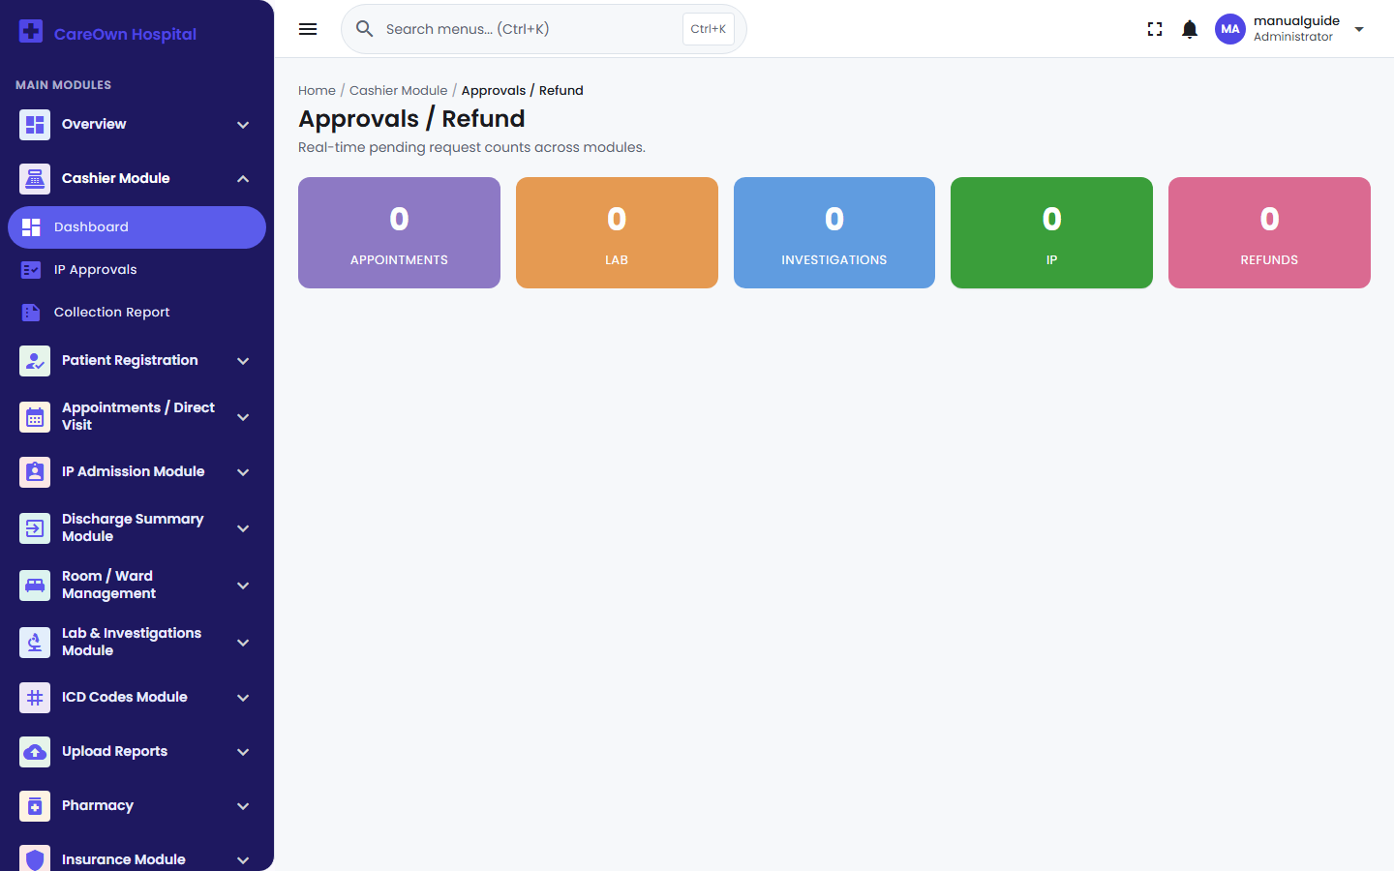
Cashier Dashboard

Navigation: IP Billing screen → Amount Received

To collect money during the stay (a deposit, an interim payment, or final settlement):

- Click Amount Received, enter the amount, a description, and the Request type (Advance / Final Settlement / Due Amount), then Submit. This queues a request for the cashier — it does not affect the bill yet.
- The cashier reviews it at Cashier Module → IP Approvals, selects a Payment Mode, and approves — this is the moment the payment is actually recorded and a receipt is printed.

Note: Two shortcuts skip the queue entirely and record an approved payment immediately: entering an Advance Amount right on the Ward Allocation screen during admission, or the Add Advance action on the IP Admissions worklist.

To reverse an approved payment, use IP Billing Master → Advance Cancel — search by the patient's UHID, then Cancel or Convert to Credit.

13. Discharge
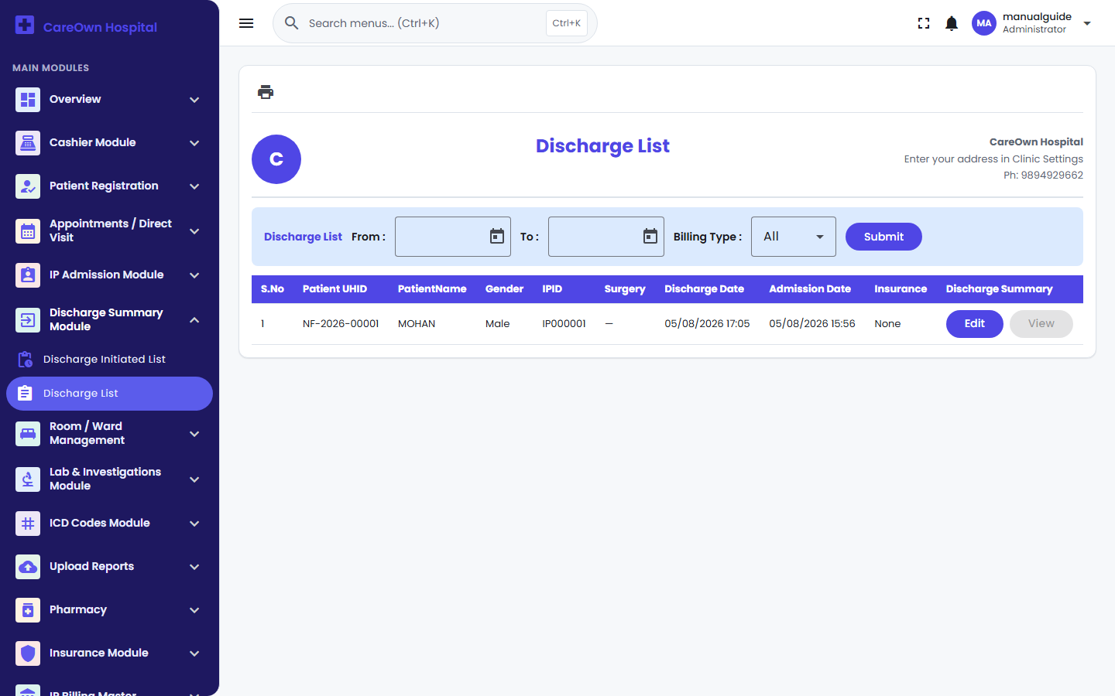
Discharge Summary list

Performed by: Billing Staff (process) / Doctor (summary)

Discharge is a deliberate two-stage process, plus a separate clinical document — three distinct things that are easy to conflate.

Flow: ADMITTED → Initiate Discharge → Finalize Discharge → DISCHARGED (room freed)

Stage 1 — Initiate Discharge: On the IP Billing screen, fill in the Discharge Date and Discharge Type (Regular Discharge / Death / Against Medical Advice / Absconding), then click Initiate Discharge. This issues a Discharge Number but the room stays occupied and nothing is settled yet.

Stage 2 — Finalize Discharge: Once ready, click Finalize Discharge. This locks in the total bill, calculates the settlement (a positive number = refund owed to the patient, negative = balance still due), marks the admission DISCHARGED, and frees the room for the next patient.

Warning: The system does not block Finalize Discharge if the bill isn't fully paid. The Balance From Patient figure is shown right on screen, but nothing stops staff from finalizing a discharge with money still owed — settling the bill first is hospital policy your staff need to follow, not something the software enforces automatically.

The Discharge Summary (clinical document):

Navigation: Discharge Summary Module → Discharge List → Edit

A separate, detailed clinical document — diagnosis, procedures, clinical examination, investigations, treatment given, medications on discharge, and follow-up advice. It can be created, edited, and printed at any point regardless of the admission's discharge status — there's no requirement to finish it before or after either discharge stage. Click Save to keep it, or open the printable version once ready.

14. Follow-up Visit
Performed by: Receptionist

Navigation: Patient Registration → Review Date Report

If a doctor set a Review Date on a patient's OP Case Sheet (Chapter 4), that patient appears here. Filter by Upcoming or Completed, then use the WhatsApp icon next to their name to send a pre-written follow-up reminder directly to their mobile number.

15. Insurance
Performed by: Billing Staff / Insurance Desk

Every insurance request in the system follows one path — there is no separate "claim" record; a claim is simply a request that reached the Approved status.

Flow: Yet to be Raised → Pending → Approved (or Rejected)

How a request starts:

- Automatically — admitting a patient with an Insurance Type set creates a skeleton request at "Yet to be Raised," pre-filled with the insurer name from the admission form.
- Manually — raise a new request directly from Insurance Module → Pre Authorization Requests, entering Policy Number, Insurer Name, and a Requested Amount.

Moving it forward:

- If it started as "Yet to be Raised," click Raise Pre-Authorization, fill in the Estimated Amount and Policy Number, and confirm — it's now Pending.
- Insurance staff review it at Insurance Approval Queue, and click Edit to record the insurer's decision: enter the Claim Amount Approved and decision date to approve, or mark it Rejected with a reason.

Note: Once a request is Approved or Rejected, that's final — a rejected request never becomes a claim later, and there is no resubmission path back to Pending. A request can be Cancelled at any point before a decision is made.

See the results at Insurance Claim Report (all Approved requests) and Insurance Rejected Report (all Rejected requests).

16. Patient Reports & WhatsApp Share
Performed by: Any front-desk/clinical staff

Navigation: Upload Reports → Report Upload

Use this to attach an external file to a patient's record — an outside lab result, a scan, any PDF or image (JPG/PNG/PDF only).

- Match the patient by name or Patient ID.
- Add any comments and choose the file.
- Click Upload.

To view or manage a patient's files later, go to View Uploaded Files and search for them. Each file has a Share PDF on WhatsApp button — unlike the Lab report share (Chapter 6.3), this one generates a real, secure link to the actual file and opens WhatsApp with it already included in the message.

Warning: A shared file link expires 24 hours after it's generated, for security. If a patient says an old link no longer works, just click Share PDF on WhatsApp again to generate a fresh one.

Deleting a file is two-step: Delete (requires a reason) moves it to Deleted Files, where a separate Delete Permanently action is needed to actually erase it — this second step cannot be undone.

17. Reports Index
Every report screen in the system, grouped by module, with a one-line description. Full field-by-field detail for each is in the relevant chapter above.

Module | Report | Shows
Appointments | Collection Report | Every billed appointment + direct-billing entry, with totals
Appointments | Refund Report | Every OP refund processed
IP Billing Master | Admission Report | Every admission with billed/paid totals and a drill-down bill view
IP Billing Master | Advance Report | Every approved cashier payment request
IP Billing Master | Advance Cancel | Search & reverse an approved payment for a patient
IP Billing Master | Cancelled Admissions | Every cancelled admission with refund status
IP Billing Master | Consultant Wise Report | Net IP billing total per consultant
IP Billing Master | IP/OP Tracking Report | Hospital-wide activity log — every create/update/cancel across every module, filterable by patient, module, or staff member
Lab & Investigations | Summary Collection Report | Every billed lab/investigation, all types combined
Lab & Investigations | Lab Detail Collection Report | Real lab-test billing only
Lab & Investigations | Investigation Detail Collection Report | Ad-hoc Investigation (X-Ray/Scan) billing only
Lab & Investigations | Cancelled Report | Every cancelled (never billed) requisition
Pharmacy Reports | Expired Report | Stock past or nearing expiry
Pharmacy Reports | Inventory Report | Current stock levels by product/batch
Pharmacy Reports | Supplier Outstanding Payments | What's owed to each supplier, with a pay-now action
Cashier | Collection Report | All-source (OP, IP, Lab, Pharmacy) collection totals, grouped by user
Cashier | IP Approvals | The pending → approved payment-request queue itself
Overview | CEO/MD Dashboard | Executive summary — bed occupancy, admissions/discharges, OP/IP revenue breakdown with charts

This is Part 2 of 3. Part 3 covers Administration, Troubleshooting, FAQ, Glossary, a Go-Live Validation Checklist, and the Deployment Guide.

